

Master of Science in Marketing
and International Business

PROGRAMME HANDBOOK
2025-2026

This Programme Handbook is subject to periodic review and changes may be made when needed. Students will be informed of the changes as and when appropriate.

(Last update: 12 August 2025)
- Programme Academic Calendar

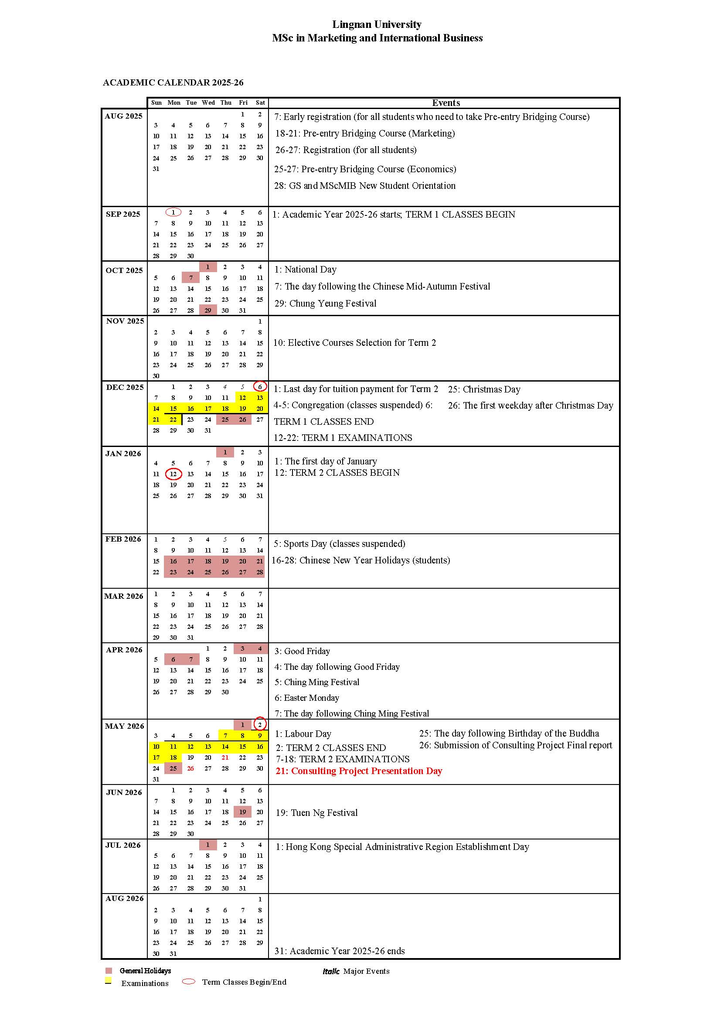

- Programme Information

- Background
The MSc in Marketing and International Business (the MScMIB or the Programme) draws on the department's high- quality teaching, active-research expertise, and industry-wide connections to enhance students' knowledge and skills in the field of marketing and international business. With an emphasis on the application of cutting- edge concepts, tools and techniques in the field of marketing and business management through a national and international context, the Programme aspires to provide a high-quality education that orientate business and non-business students to a career in marketing and international business fields through its balanced curriculum content design, liberal- art oriented small-class teaching, individualized personal advising system, and outcome-based learning assessments.

- Aims and Programme Intended Learning Outcomes
The MSc in Marketing and International Business Programme aims to:
- provide students with an opportunity to develop their knowledge and skills in specialist areas of marketing and international business;
- orientate students with diverse academic backgrounds with a critical awareness of contemporary strategic marketing and international business issues especially in China;
- enable students to apply relevant marketing and international business theories and techniques to addressing opportunities and problems faced by practitioners in Hong Kong and China; and
- equip future business leaders with sound knowledge and skills needed in developing socially responsible and ethical strategies to deal with dynamic marketing and international business environments.

Programme Intended Learning Outcomes (PILOs)
PILO1: Students will develop a comprehensive understanding of marketing and international
business theories and practices.
PILO2: Students will cultivate critical thinking and problem-solving skills to identify and
address complex business challenges in the global context creatively.
PILO3: Students will foster the ability to collect, analyze, and interpret marketing and
international business data to support evidence-based decision-making.
PILO4: Students will develop strong interpersonal, communication, and teamwork skills to
engage with diverse stakeholders and drive successful project implementation.
PILO5: Students will develop ethical and socially responsible perspectives in marketing and
international practices.

- Mode of Study
Full-time

- Normal and Maximum Duration of Study
Mode of Study | Minimum Study Period | Maximum Study Period
Full-time | 1 year | 3 years

- Medium of Instruction
English

- Contributing Departments/Units/External Partners
Host Department:
Department of Marketing and International Business
Supporting Departments:
Department of Management
Department of Operations and Risk Management
Department of Accountancy
Taught Postgraduate Programmes Office (TPO)

- Programme Structure
- Curriculum
Course Code | Course Title | Credit
Core Courses
MIB501 | Consumer Behaviour | 3
MIB502 | Applied Marketing Research | 3
MIB503 | International Marketing Management | 3
MIB504 | International Trade and Investment | 3
MIB506 | Consulting Project | 6
MIB605 | E-Commerce and Social Media Marketing | 3
Elective Courses (Choose any 3)
MIB505 | Services Marketing and Customer Relationship Management | 3
MIB601 | Innovation Management and Digital Transformation | 3
MIB602 | Integrated Marketing Communications | 3
MIB604 | Sales and Retail Management | 3
MIB606 | Financial Services Marketing | 3
MIB607 | Big Data Marketing | 3
ORM513 | Purchasing and Logistics Management for eBusiness | 3
MGT604 | Strategic Management | 3
ACT615 | Introduction to Python Programming | 3
ESG503 | ESG Accounting and Disclosure | 3
ESG511 | Sustainability in Hong Kong and Mainland China | 3
ORM545 | Cloud-based Solutions for Digital Business Transformation | 3
Total |  | 30

- List of Courses for 2025-26
Course Code | Course Title
Core Courses
MIB501 | Consumer Behaviour
MIB502 | Applied Marketing Research
MIB503 | International Marketing Management
MIB504 | International Trade and Investment
MIB506 | Consulting Project
MIB605 | E-Commerce and Social Media Marketing
Elective Courses (Choose any 3)
MIB601 | Innovation Management and Digital Transformation
MIB602 | Integrated Marketing Communications
MIB604 | Sales and Retail Management
MIB606 | Financial Services Marketing
MIB607 | Big Data Marketing
ORM513 | Purchasing and Logistics Management for eBusiness
MGT604 | Strategic Management
ACT615 | Introduction to Python Programming
ESG503 | ESG Accounting and Disclosure
ESG511 | Sustainability in Hong Kong and Mainland China
ORM545 | Cloud-based Solutions for Digital Business Transformation

- Curriculum Mapping
Programme Intended Learning Outcomes (PILO) | REQUIRED COURSES |  |  |  |  |  | ELECTIVE COURSES
Programme Intended Learning Outcomes (PILO) | MIB501 Consumer Behaviour | MIB502 Applied Marketing Research | MIB503 International Marketing Management | MIB504 International Trade and Investment | MIB506 Consulting Project | MIB605 E-Commerce and Social Media Marketing | Marketing Cluster |  |  |  |  |  | International Business Cluster
 |  |  |  |  |  |  | MIB505 Services Marketing and Customer Relationship Management | MIB601 Innovation Management and Digital Transformation | MIB602 Integrated Marketing Communications | MIB604 Sales and Retail Management | MIB606 Financial Services Marketing | MIB607 Big Data Marketing | MGT604 Strategic Management | ORM513 Purchasing and Logistics Management for eBusiness | ACT615 Introduction to Python Programming | ESG503 ESG Accounting and Disclosure | ESG511 Sustainability in Hong Kong and Mainland China | ORM545 Cloud-based Solutions for Digital Business Transformation
1. Understand the theories and practices of marketing and international business | √ | √ | √ | √ |  |  | √ | √ | √ | √ | √ | √
2. Demonstrate a global outlook and an understanding of cultural diversity and their implications for marketing and management |  |  | √ | √ |  |  |  |  | √ |  |  |  |  | √
3. Analyze consumer and organizational buyer behaviour and its implications for marketing strategy | √ | √ |  |  | √ |  | √ |  |  | √ | √
4. Demonstrate an understanding of international business concepts and trends and an ability to internationalize business models and practices |  |  |  | √ | √ |  |  | √ |  |  |  | √ | √ | √ | √ | √ | √ | √
5. Apply consulting skills to undertake international marketing decisions and operations |  |  | √ | √ | √ | √ |  |  |  |  |  | √ | √ | √ | √ | √ | √ | √

- Student Progression Requirements
- A student should be subject to an academic review at the end of each term generally. In the case where a student enrolled in less than 6 credits in a term, the academic review shall be done when he/she has cumulatively enrolled in 6 credits or more.

- A student whose Cumulative G.P.A. is below 2.50 at the academic review will be put on academic probation in the following term or discontinued from studies as prescribed by Regulation 17.2).

- At the end of the term in which the student on academic probation has cumulatively enrolled in 6 or more credits, if he/she obtains a Cumulative G.P.A. of 2.50 or above, probation will be lifted. Otherwise, his/her studies will be discontinued.

- A student may be put on academic probation for only one time during his/her whole period of study on the programme. After the academic probation is lifted and the student continued on the programme, the student will be discontinued from his/her studies if his/her Cumulative G.P.A. is below 2.50 at an academic review.

- Individual programmes may set additional requirements governing students’ progression, and such requirements set by the programme would be considered for progression when reviewing the academic performance of students at the academic review.

- A warning concerning the need to improve his/her academic performance should be issued to a student whose Cumulative G.P.A. is at or above the level required for progression but below the level for graduation. The warning should be sent to a student whose Cumulative G.P.A. is at or above 2.50 but below 2.67 (which is the minimum required for graduation asstipulated in Regulation 18.3).

- Discontinuation of Studies
[Please also refer to Section 17 of the Regulations Governing Taught Doctoral/Master’s Degree Programmes (effective from 2025-26 intake)]

- The Senate may, on the recommendation of the Postgraduate Studies Committee (the Committee), discontinue the studies of a student at any time on the grounds of the candidate’s unsatisfactory performance or failure to comply with specific stipulations in Regulations Governing Taught Doctoral/Master’s Degree Programmes.

- The studies of a student will normally be discontinued if,
- he/she fails to have his/her academic probation lifted at the end of the term when he/she has taken cumulatively 6 or more credits since he/she has been put on probation, or
- his/her CGPA is below 2.50 at an academic review after the academic probation is lifted and the student continues on the programme;
- he/she fails to fulfill progression requirements specified in Section 2.8; or
- he/she fails to fulfill all requirements for graduation within the maximum study period.

- A student’s academic standing, as referred to in Section 2.9.2, is subject to the approval of the Senate upon the recommendation of the Committee.

- A student whose studies have been discontinued may appeal through the Registrar against the decision. Details are stipulated in Section 9 of the Regulations Governing University Examinations and Course Work.

- Graduation Requirements
- A student will be evaluated for graduation according to the schedule announced by the University for each conferment exercise if he/she satisfies all the conditions for an award. If a student is not allowed to graduate, he/she will be re-evaluated for graduation in the subsequent conferment exercises.
- The student should have fulfilled all graduation requirements stipulated in the curriculum of his/her programme. The University reserves the right to make amendments to academic programmes from time to time as approved by the Senate.
- The CGPA that a student should have obtained for graduation shall not be below 2.67.
- A student is required to fulfil an exit requirement on English language competency before graduation. The requirement is considered fulfilled if the student has obtained a band score of
- 6.5 or above in IELTS, or 79 (internet-based test) in TOEFL, or the student has met the programme’s specific exit requirement on English language competency as approved by the University.
- A student is required to graduate as soon as he/she satisfies all the conditions for an award by the cut-off date of graduation evaluation concerned.
- A student’s eligibility for graduation is subject to Senate approval.

- Award Classification

Award Classification | Minimum Cumulative GPA
Distinction | 3.50
Pass | 2.67
*There is no classification for an intermediate award.

- Intermediate Award
Students will be awarded a Postgraduate Diploma in Marketing and International Business (市場及國際企業深造文憑) if they complete any four required courses with a minimum CGPA of 2.50.

Acceptance of an intermediate award implies an intention not to complete the final award. Where students seek re-admission to complete the award, readmission cannot be guaranteed. Where students are readmitted and go on to complete the award, their transcripts will indicate that the intermediate award has been superseded.

- Degree Conferment Date
“Awards of this programme will be conferred on 31 March, 31 July, 31 August or 15 November* in each academic year. If students have a preferred degree conferment date, they should indicate it during course commencement.”
*Subject to revision by the University.

- TPg Programme Attendance Requirement
Students are required to attend lectures, tutorials, and other class activities, including tests and examinations, and to complete all assigned work for the courses in which they are enrolled. Punctual and regular attendance is expected to meet the satisfaction of the lecturers. Each course may have specific attendance requirements, and appropriate sanctions may be approved by the Board of Examiners if necessary.

For TPg programmes, a minimum attendance of 80% is generally required for all courses, which is a graduation prerequisite. Students who fail to meet this attendance requirement may be prohibited from sitting for examinations. This requirement is communicated to students at the beginning of their studies, and it is their responsibility to fulfill the attendance criteria throughout the duration of the programme.
Students arriving more than 30 minutes late for class will generally be marked as absent, and individual course instructors may impose stricter attendance requirements for specific courses. Teaching assistants will record attendance at the start of each class, and occasional spot checks may occur during the session. To ensure accurate records, students must follow the sign-in procedures and inform the teaching assistant of their presence.

If students fail to notify the teaching assistant at the beginning of class, they may be marked absent. Retrospective attendance recording may be considered if valid evidence of attendance is submitted. Additionally, students who leave class early without justifiable reasons and without notifying the course instructor may also be marked absent, despite being recorded as present at the beginning.

The Programme Office may arrange random second sign-ins during or after class without prior notice. If students do not sign out or provide proof of full participation, they may be recorded as absent, even if they signed in at the beginning.

- Exam Regulations
Students are responsible for checking the dates, times, and locations of their examinations from the examination timetables and must present themselves at the designated place and time. During examinations, students must not use any unapproved materials or electronic communication devices, such as mobile phones and smart watches, all of which must be switched off.

If a student is suspected of academic misconduct during an examination, the invigilator will inform them on the spot and remove any unapproved materials found. While the student will be allowed to complete the examination, they will be warned that they may be disqualified from that examination and face disciplinary action.

Students who are unable to attend or complete scheduled examinations due to unavoidable circumstances, such as illness, family bereavement, or accidents, may be eligible for supplementary assessments, provided they can provide documentary evidence that satisfies the Board of Examiners. Those who cannot sit for an examination for medical or other compelling reasons acceptable to the Programme Office must apply in writing with supporting documentation for a supplementary assessment. Documentary evidence should be submitted as soon as possible and no later than one week after the examination. Any medical documentation should be up-to-date and relevant to the examination period.

- Early Alert System
- The Early Alert System aims to identify students experiencing difficulties in their studies and provide timely support.
- Programme Offices shall:
  - request teachers, around the middle of the term, to report students who may require special attention (e.g. frequent absences, poor performance in tests and/or midterms);
  - compile a warning list for each course and cross-check with other teachers;
  - issue mid-term warnings to students who have not performed well; and
  - maintain ongoing communication and monitoring of the students concerned.

- Programme Extra-Curricular Activities
The MScMIB programme allocates sufficient resources to develop a variety of professional development activities, including guest seminars, company visit and study tour.
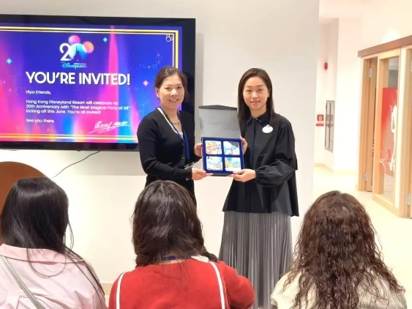 |   

- Scholarships and Financial Assistance
Scholarships
Scholarships might be considered for outstanding students on the basis of academic merit. All students admitted to the programme will automatically be candidates for the scholarships.

Local students may apply for the Extended Non-Means-Tested Loan Scheme offered by the HKSAR Government. For eligibility and details, please visit the Working Family and Student Financial Assistance Agency’s website.
- Official Communication Channel
Email is the official communication channel in Lingnan University. Students should use their Lingnan student email account to exchange messages with members of the University.

- Programme Contact Information

Contact | Telephone | Email | Address
Programme Director  Prof. YAN Aihua | (852) 2616 7930 | aihuayan@LN.edu.hk | SEK112/7, 1/F, SEK Building
Programme Office | (852) 2616 7738 | mscmib@LN.edu.hk | SEK112/1, 1/F, SEK Building
Administrative Officer  Mr Ivon WEI | (852) 2616 7738 | zhifengwei2@LN.edu.hk | SEK112/1, 1/F, SEK Building
Administrative Officer  Ms Sindy YIP | (852) 2616 8321 | sh4yip@LN.edu.hk | SEK112/5, 1/F, SEK Building
Teaching Assistant  Ms Summer JIANG | (852) 2616 8328 | xueyaojiang@LN.edu.hk | SEK113, 1/F, SEK Building

